Add Strings LeetCode:
https://leetcode.com/problems/add-strings/description/
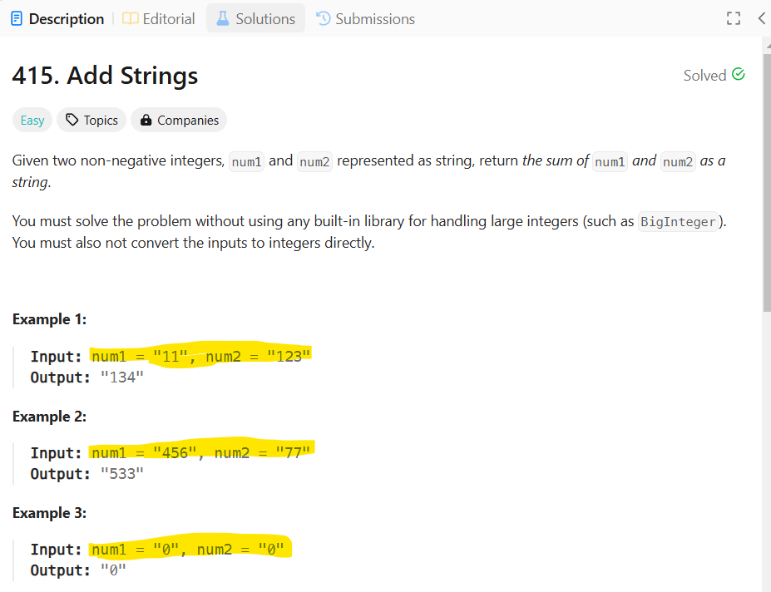
We will convert string to BigInteger
----------------------------------------------------------------------------------------------------
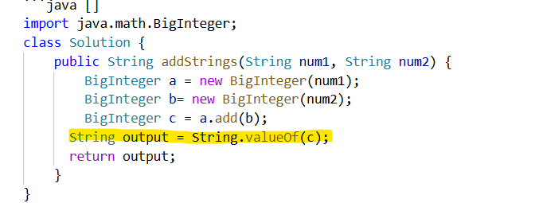
-----------------------------------------------------------------------------------------------------
[2]Longest Common Prefix :
https://leetcode.com/problems/longest-common-prefix/description/
https://github.com/nikoo28/java-solutions/blob/master/src/main/java/leetcode/easy/LongestCommonPrefix.java
https://www.youtube.com/watch?v=wtOQaovlvhY&t=615s
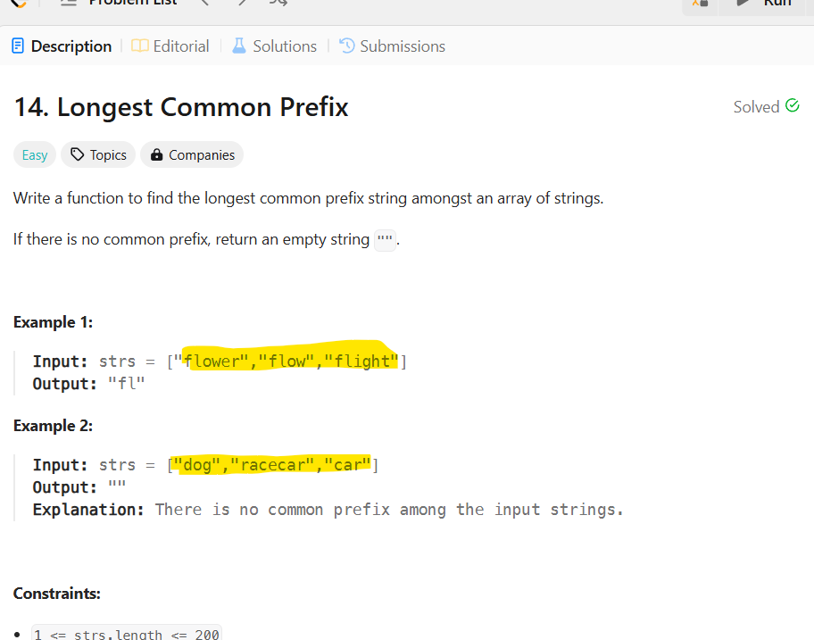
In this sort we will sort the array first based on smallest and longest and then we will compare in the letters of smallest will contain all letter in longest String
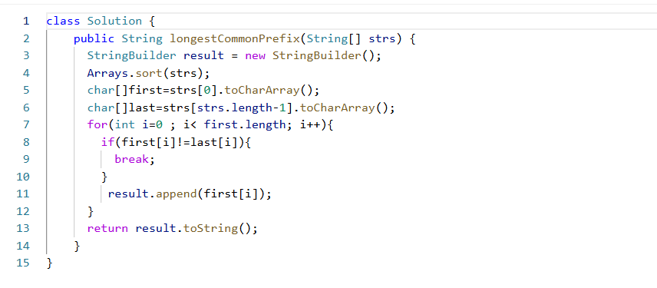
[3]Valid Palindrome-!!
https://leetcode.com/problems/valid-palindrome-ii/description/
https://github.com/nikoo28/java-solutions/blob/master/src/main/java/leetcode/easy/ValidPalindromeII.java
https://www.youtube.com/watch?v=wX3-411uJH0&t=1s
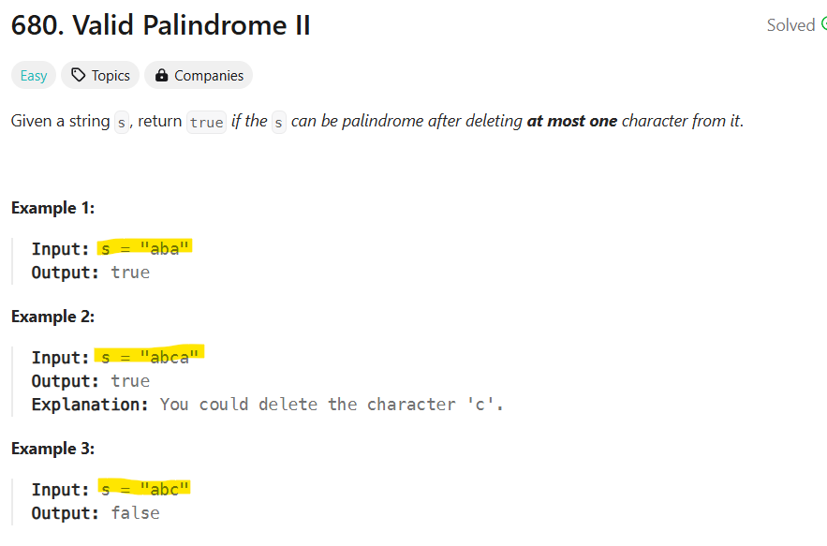
In this we will compare from two pointer approach we will compare from left and right for this to palindrome both characters from left should equal to right except the exception i==j
To skip the one character you can use left+1 or right-1 -> you can use same approach.
To check the sample palindrome :
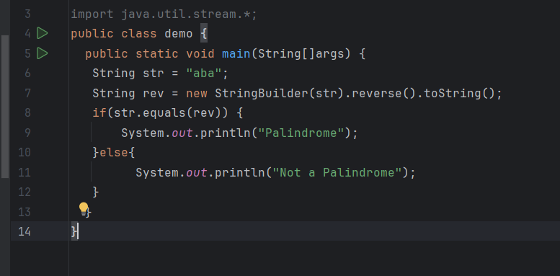
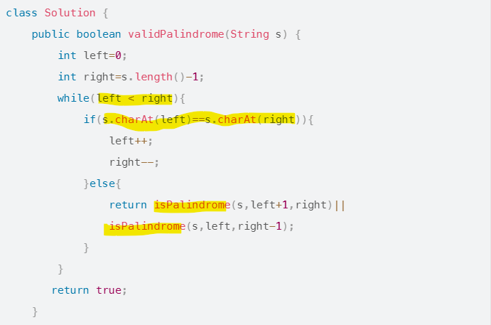
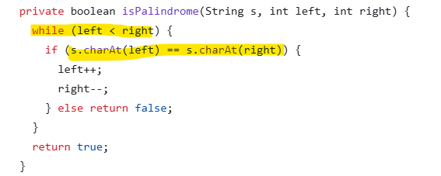
-------------------------------------------------------------------------------------------------------------
Find the index of the First Occurrence in a String
haystack=sadbutsad -> length=9 index from 0 to 8
needle=sad -> length=3 index from 0 to 2
so when i=0 , j should minimum be 3 and when i increases j should also increment upto
haystack.length()
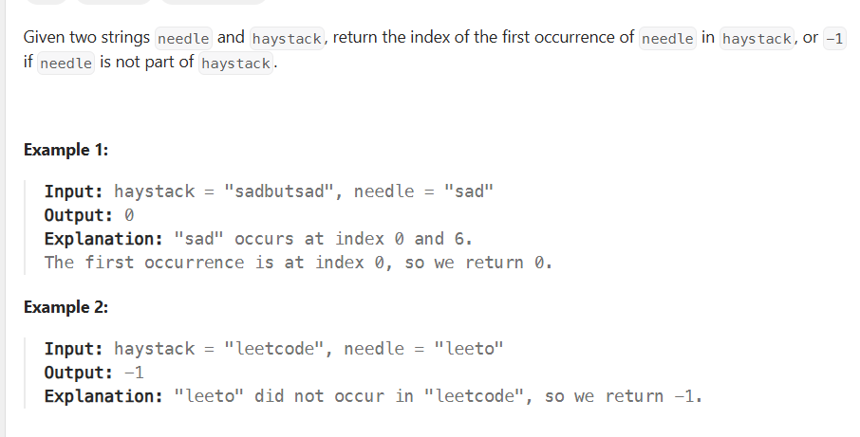
------------------------------------------------------------------------------------------------------
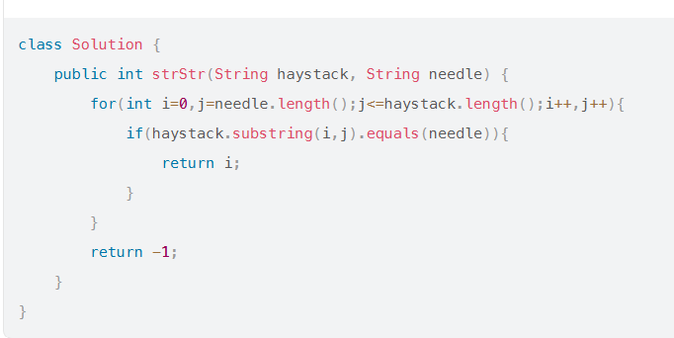
[5]Valid Palindrome :
https://leetcode.com/problems/valid-palindrome/description/
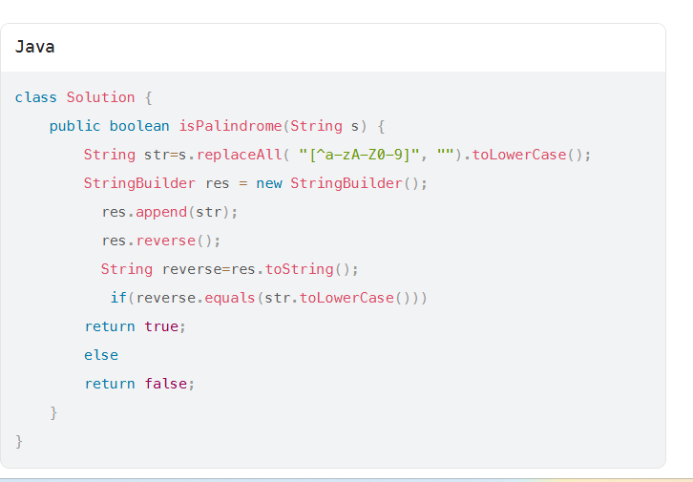
[6]Reverse Words in a String
https://leetcode.com/problems/reverse-words-in-a-string/description/
[1].trim() is used to remove leading and trailing spaces.
[2]To remove extra space between words-> String output=s.replaceAll(\\s+,” ”);
[3]To append array of string words to a single string -> String.join(“ “,rstrs);
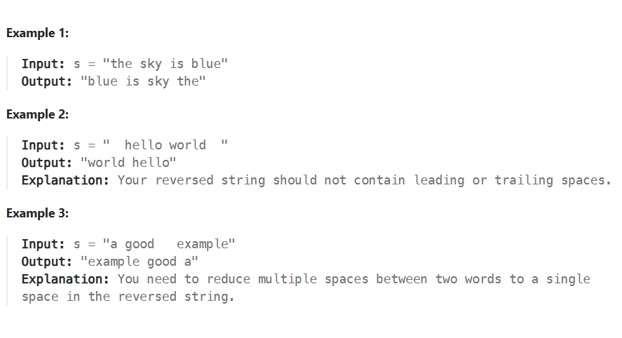
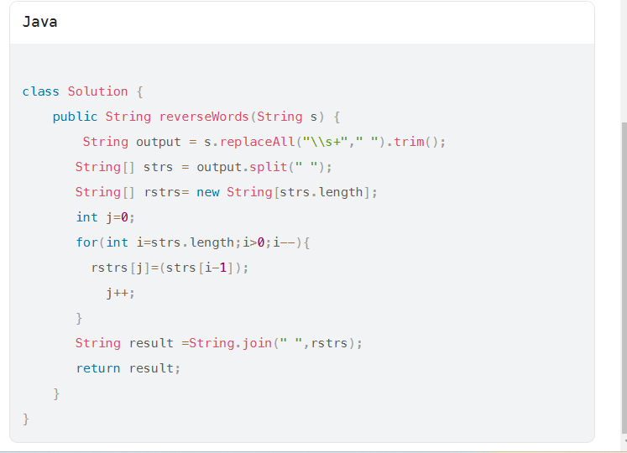
[7]Valid Anagram
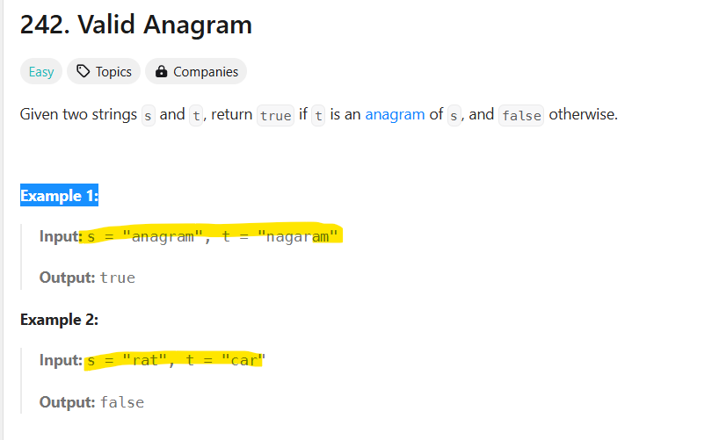
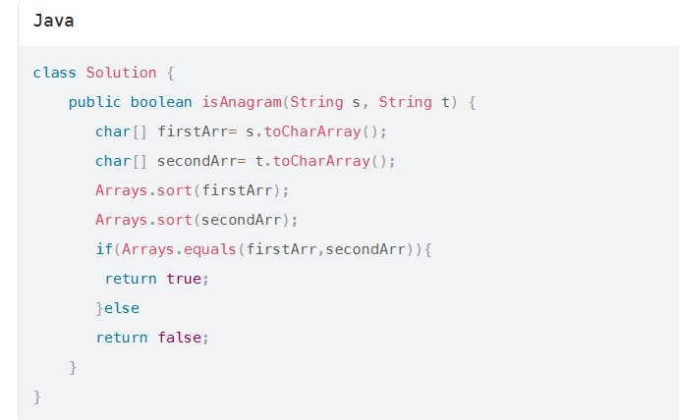
https://leetcode.com/problems/kth-largest-element-in-an-array/description/
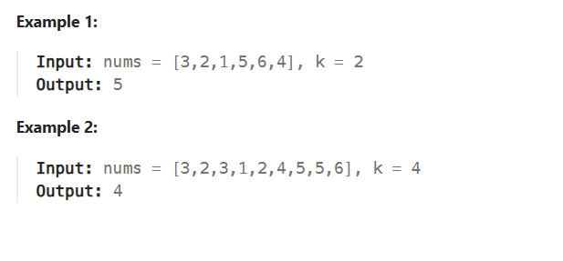
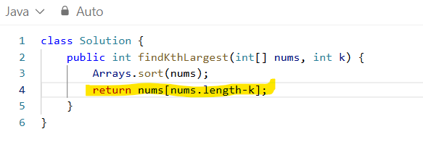
Valid Paranthesis :
https://leetcode.com/problems/valid-parentheses/description/
https://www.youtube.com/watch?v=TaWs8tIrnoA
Code :
class Solution {
public boolean isValid(String s) {
Stack<Character> stack = new Stack<>();
for(int i=0;i<s.length();i++){
char ch = s.charAt(i);
if(ch == '(' || ch == '{' || ch =='['){
stack.push(ch);
}else{
if(stack.isEmpty()){
return false ;
}
char top = stack.peek();
if( ch == ')' && top !='('){
return false;
} else if ( ch == '}' && top !='{'){
return false;
} else if ( ch == ']' && top !='['){
return false;
}else{
stack.pop();
}
}
}
if(!stack.isEmpty()){
return false;
}else{
return true;
}

}
}
------------------------------------------------------------------------------------------------------------
https://leetcode.com/problems/minimum-remove-to-make-valid-parentheses/
Minimum Remove to Make Valid Parentheses
https://www.youtube.com/watch?v=PAfa1FUG7W8 Explanation::
Brute force approach :
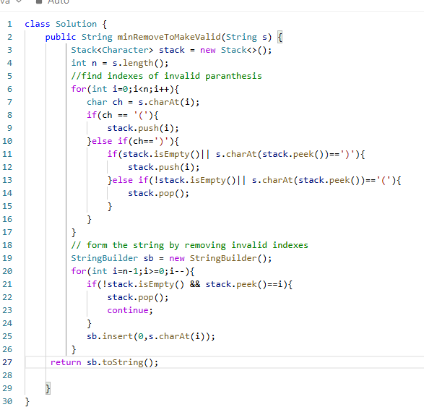
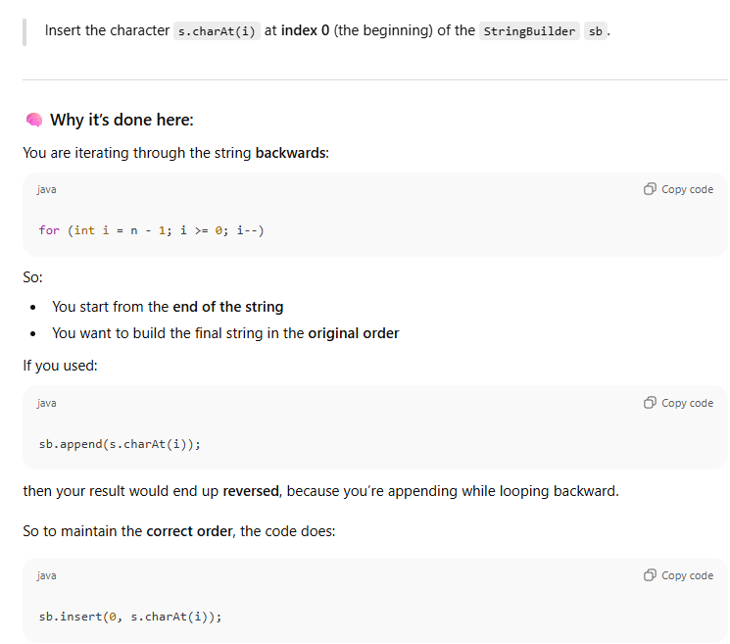
Optimize solution :
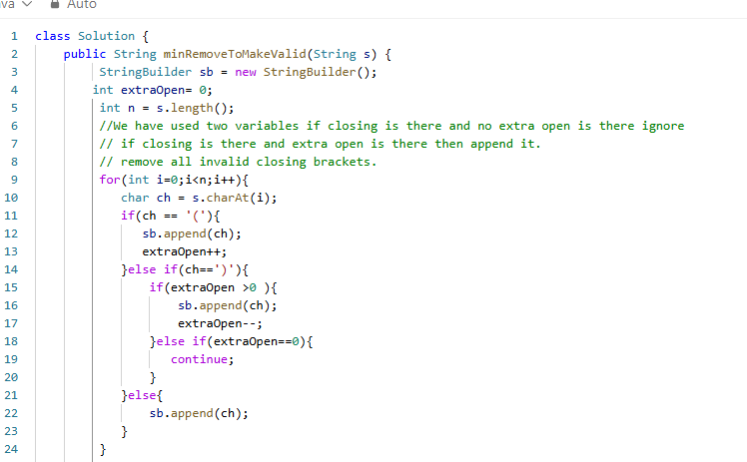
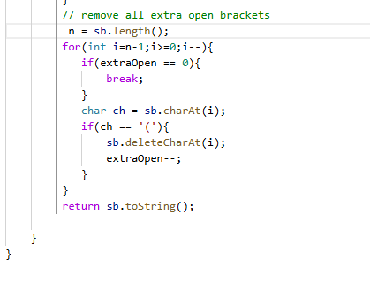
Longest Substring Without Repeating Characters
https://leetcode.com/problems/longest-substring-without-repeating-characters/
https://www.youtube.com/watch?v=U2ppEzBaMck



